Họ và tên : Phạm Văn Phúc

MSSV : 522H0068

Cau 1

Code

import java.util.Scanner;

public class Lab3 {

public static void showArr(int *arr*[]) {

for (int i = 0; i < *arr*.length; i++) {

System.out.print(*arr*[i] + " ");

}

System.out.println();

}

public static boolean checkEle(int *arr*[], int *k*) {

boolean a = false;

for (int i = 0; i < *arr*.length; i++) {

if (*arr*[i] == *k*) {

a = true;

break;

}

}

return a;

}

public static int[] delEle(int *arr*[], int *x*) {

int d = 0;

for (int i = 0; i < *arr*.length; i++) {

if (*arr*[i] == *x*) {

d = i;

break;

}

}

for (int i = d; i < *arr*.length - 1; i++) {

*arr*[i] = *arr*[i + 1];

}

int[] arr1 = new int[*arr*.length - 1];

for (int i = 0; i < arr1.length; i++) {

arr1[i] = *arr*[i];

}

return arr1;

}

public static void insertEle(int *arr*[], int *x*, int *d*) {

for (int i = *arr*.length - 1; i > *d*; i--) {

*arr*[i] = *arr*[i - 1];

}

*arr*[*d*] = *x*;

}

public static void arangeArr(int *arr*[]) {

int tmp = 0;

for (int i = 0; i < *arr*.length - 1; i++) {

for (int j = i + 1; j < *arr*.length; j++) {

if (*arr*[i] > *arr*[j]) {

tmp = *arr*[i];

*arr*[i] = *arr*[j];

*arr*[j] = tmp;

}

}

}

}

public static int[] findDupl(int *arr*[]) {

int dem = 0, dem1 = 0;

for (int i = 0; i < *arr*.length; i++) {

dem = 0;

for (int j = 0; j < *arr*.length; j++) {

if (*arr*[i] == *arr*[j]) {

dem += 1;

}

}

if (dem > 1) {

dem1 += 1;

}

}

int[] arr1 = new int[dem1];

int t = 0;

for (int i = 0; i < *arr*.length; i++) {

dem = 0;

for (int j = 0; j < *arr*.length; j++) {

if (*arr*[i] == *arr*[j]) {

dem += 1;

}

}

if (dem > 1) {

arr1[t] = *arr*[i];

t += 1;

}

}

arangeArr(arr1);

int d = 1;

for (int i = 0; i < arr1.length - 1; i++) {

if (arr1[i] != arr1[i + 1]) {

d += 1;

}

}

int[] arr2 = new int[d];

arr2[0] = arr1[0];

d = 1;

for (int i = 0; i < arr1.length - 1; i++) {

if (arr1[i] != arr1[i + 1]) {

arr2[d] = arr1[i + 1];

d += 1;

}

}

return arr2;

}

public static void main(String[] *args*) {

Scanner sc = new Scanner(System.in);

System.out.println("522H0068 - Pham Van Phuc");

System.out.println("Moi nhap so phan tu cua mang ");

int n = sc.nextInt();

System.out.println("Moi nhap cac phan tu cua mang :");

int[] arr = new int[n];

for (int i = 0; i < arr.length; i++) {

arr[i] = sc.nextInt();

}

// task1

System.out.println("Moi nhap phan tu muon xoa : ");

int k = sc.nextInt();

System.out.println(checkEle(arr, k));

if (checkEle(arr, k) == true) {

int[] arr1 = new int[n - 1];

arr1 = delEle(arr, k);

arr = arr1;

}

// task2

System.out.println("Moi nhap phan tu muon chen va vi tri muon chen");

int x = sc.nextInt();

int d = sc.nextInt();

while (d > arr.length) {

System.out.println("Vi tri nam ngoai mang. Nhap lai");

d = sc.nextInt();

}

insertEle(arr, x, d);

System.out.println("Sau khi chen la : ");

showArr(arr);

// task 3

System.out.println("Mang chua cac phan tu trung nhau la");

showArr(findDupl(arr));

sc.close();

}

}

Màn hình chạy :

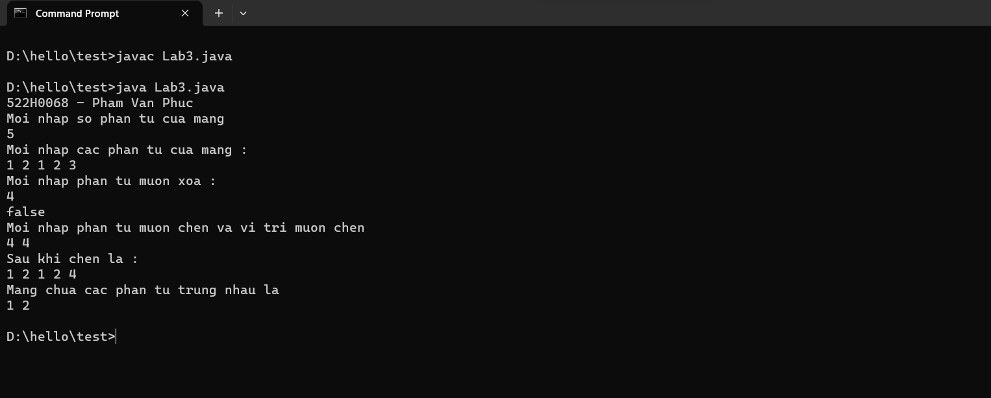

Câu 2

Code :

import java.util.Scanner;

public class test {

public static void showMatrix(int *arr*[][]) {

for (int i = 0; i < *arr*.length; i++) {

for (int j = 0; j < *arr*[i].length; j++) {

System.out.print(*arr*[i][j] + " ");

}

System.out.println();

}

}

public static int[][] addMatrix(int *arr1*[][], int *arr2*[][]) {

int arr3[][] = new int[3][3];

for (int i = 0; i < 3; i++) {

for (int j = 0; j < 3; j++) {

arr3[i][j] = *arr1*[i][j] + *arr2*[i][j];

}

}

return arr3;

}

public static int[][] mulMatrix(int *arr*[][], int *n*) {

int arr3[][] = new int[3][3];

for (int i = 0; i < 3; i++) {

for (int j = 0; j < 3; j++) {

arr3[i][j] = *arr*[i][j] * *n*;

}

}

return arr3;

}

public static void main(String[] *args*) {

Scanner input = new Scanner(System.in);

int arr1[][] = {

{ 1, 2, 3 },

{ 4, 5, 6 },

{ 7, 8, 9 }

};

int arr2[][] = {

{ 9, 8, 7 },

{ 6, 5, 4 },

{ 3, 2, 1 }

};

System.out.println("522H0068 - Pham Van Phuc");

System.out.println("Ma tran sau khi cong lai la ");

showMatrix(addMatrix(arr1, arr2));

System.out.println("Moi nhap so muon nhan vao :");

int n = input.nextInt();

System.out.println("Ma tran 1 sau khi nhan la : ");

showMatrix(mulMatrix(arr1, n));

input.close();

}

}

Màn hình chạy:

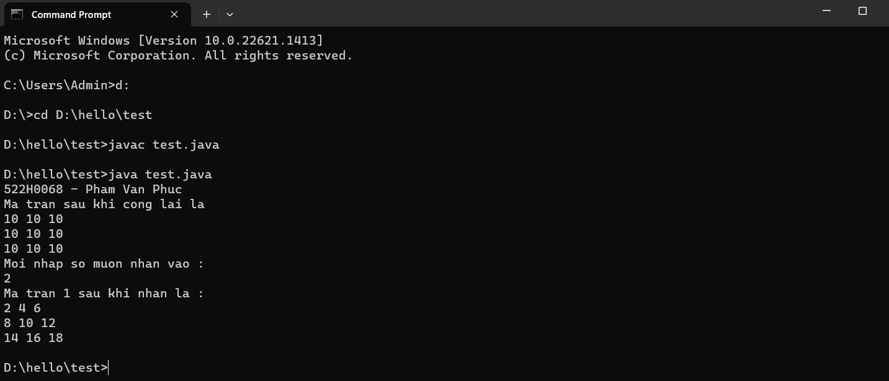

Câu 3

Code :

import java.util.Scanner;

public class Lab3 {

public static int countName(String *s*) {

int dem = 0;

char[] c = *s*.toCharArray();

for (int i = 0; i < *s*.length(); i++) {

if (c[i] == ' ') {

dem += 1;

}

}

return dem + 1;

}

public static String fnlName(String *s*) {

String s1[] = *s*.split(" ");

String s2 = "";

s2 = s2.concat(s1[0]);

s2 = s2.concat(" ");

s2 = s2.concat(s1[countName(*s*) - 1]);

return s2;

}

public static String middleName(String *s*) {

String s1[] = *s*.split(" ");

String s2 = "";

for (int i = 1; i < countName(*s*) - 1; i++) {

s2 = s2.concat(s1[i]);

s2 = s2.concat(" ");

}

return s2;

}

public static String capitalizeName(String *s*) {

char[] c = *s*.toCharArray();

c[0] = Character.toUpperCase(c[0]);

for (int i = 1; i < *s*.length(); i++) {

if (c[i] == ' ') {

c[i + 1] = Character.toUpperCase(c[i + 1]);

}

}

*s* = new String(c);

return *s*;

}

public static String vowelName(String *s*) {

char[] s1 = *s*.toCharArray();

for (int i = 0; i < *s*.length(); i++) {

char c = s1[i];

if (c == 'u' || c == 'e' || c == 'o' || c == 'a' || c == 'i') {

s1[i] = Character.toUpperCase(s1[i]);

} else if (c == 'U' || c == 'E' || c == 'O' || c == 'A' || c == 'I') {

s1[i] = Character.toUpperCase(s1[i]);

} else {

s1[i] = Character.toLowerCase(s1[i]);

}

}

*s* = new String(s1);

return *s*;

}

public static void main(String[] *args*) {

Scanner input = new Scanner(System.in);

System.out.println("522H0068 - Pham Van Phuc");

System.out.print("Enter the name : ");

String s = input.nextLine();

System.out.println("Name after capitalize is : " + capitalizeName(s));

s = capitalizeName(s);

System.out.println("Final and Last name is : " + fnlName(s));

System.out.println("Middle name is : " + middleName(s));

System.out.println("After upcase vowel and lower conso is : " + vowelName(s));

input.close();

}

}

Màn hình chạy:

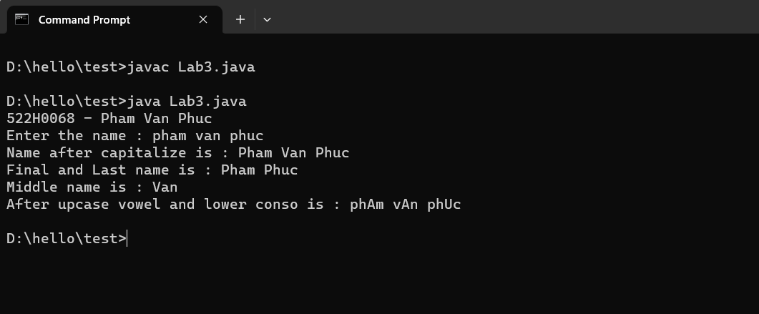

Câu 4

Code :

import java.util.Scanner;

public class Lab3 {

public static int countName(String *s*) {

int dem = 0;

char[] c = *s*.toCharArray();

for (int i = 0; i < *s*.length(); i++) {

if (c[i] == ' ') {

dem += 1;

}

}

return dem + 1;

}

public static int checkPalin(String *s*) {

StringBuilder ss = new StringBuilder(*s*);

ss.reverse();

String s1 = new String(ss);

if (*s*.compareTo(s1) == 0)

return 1;

return 0;

}

public static void main(String[] *args*) {

Scanner input = new Scanner(System.in);

System.out.println("522H0068 - Pham Van Phuc");

System.out.print("Enter the string: ");

String s = input.nextLine();

System.out.println("Length of the string is " + s.length());

System.out.println("Number of word in the string is " + countName(s));

System.out.println("Enter the string want to concat ");

String s1 = input.nextLine();

s = s.concat(" " + s1);

System.out.println("String after concat is : " + s);

if (checkPalin(s) == 1) {

System.out.println("Is palindrome string");

} else {

System.out.println("Not is palindrome string");

}

input.close();

}

}

Màn hình chạy:

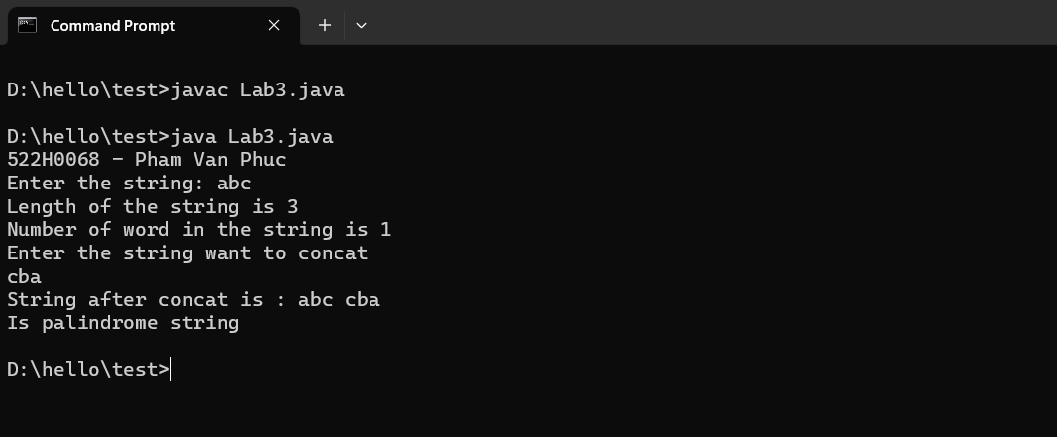

Câu 5

Code :

import java.util.ArrayList;

public class Main {

// loai bo cac dau cau

public static String removeDC(String *s*) {

String DC = ".,;:?!-()[]{}\"'";

StringBuilder sb = new StringBuilder(*s*);

for (int i = 0; i < sb.length(); i++) {

char c = sb.charAt(i);

if (DC.indexOf(c) != -1) {

sb.deleteCharAt(i);

i--;

}

}

return sb.toString();

}

// tach mang thanh cac tu

public static String[] splitWords(String *s*) {

return *s*.split(" ");

}

// đếm số lần xuất hiện của từ trong mảng

public static int countOccurrences(String[] *arr*, String *word*) {

int count = 0;

for (String s : *arr*) {

if (s.equals(*word*)) {

count++;

}

}

return count;

}

// loại bỏ các từ trùng lặp

public static String[] removeDuplicates(String[] *arr*) {

ArrayList<String> list = new ArrayList<String>();

for (String s : *arr*) {

if (!list.contains(s)) {

list.add(s);

}

}

String[] result = new String[list.size()];

for (int i = 0; i < list.size(); i++) {

result[i] = list.get(i);

}

return result;

}

// hiển thị mảng kết quả

public static void showStringArray(String[] *words*, int[] *counts*) {

for (int i = 0; i < *words*.length; i++) {

System.out.println(*words*[i] + ": " + *counts*[i]);

}

}

public static void main(String[] *args*) {

System.out.println("522H0068_PhamVanPhuc");

String paragraph = "You are living on a Plane. What you style Flatland is the vast level surface of what I may call a fluid, on, or in, the top of which you and your countrymen move about, without rising above it or falling below it";

// chuyen ve in thuong

paragraph = paragraph.toLowerCase();

// xoa dau cau

paragraph = removeDC(paragraph);

String[] words = splitWords(paragraph);

words = removeDuplicates(words);

// đếm số lần xuất hiện của từ

int[] counts = new int[words.length];

for (int i = 0; i < words.length; i++) {

counts[i] = countOccurrences(splitWords(paragraph), words[i]);

}

showStringArray(words, counts);

}

}

Màn hình chạy:

